Intro to race notebook

Second most common bias in NYC after religious is racial/ancestry/ethnicity bias.

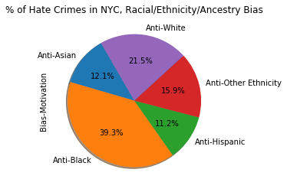

We want to connect the number of hate crime with the minority population in certain neighborhoods.

We are going to use census data to get the percentage of minority population by zip code.

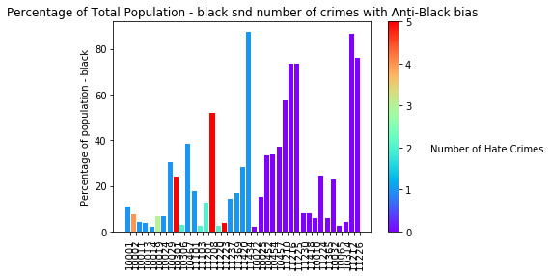

Black population 26% of NYC total.

Turns out Percentage of Black population has no effect on the number of hate crimes with anti-black bias.

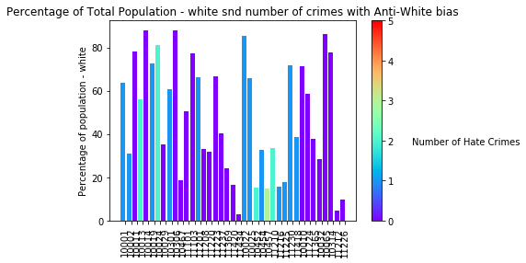

White population 33% of NYC total.

No strong correlation, but 3 out of 5 top dangerous zipcodes for whites have white population of less than a third.

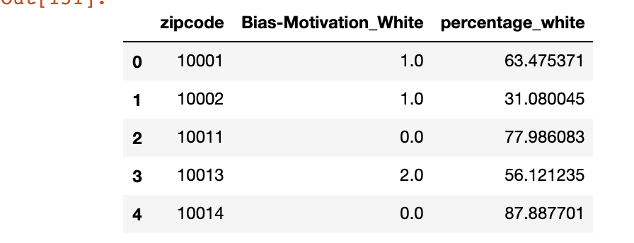

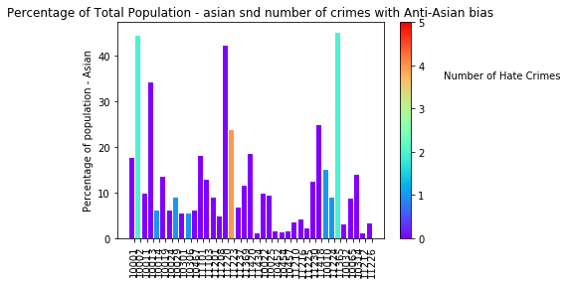

Asian - 13% of NYC population.

Only 12% of racial bias hate crimes fall on Asian population and they peak in zip codes with higher Asian population.

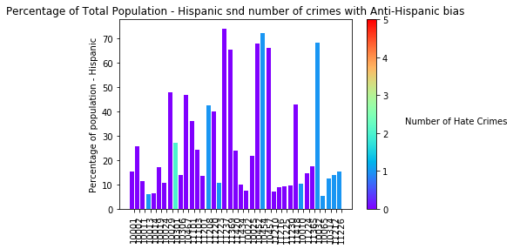

Hispanic 26% of NYC population, no correlation.

Conclusion: Racial bias is more spread out and is not concentrated in specific neighborhoods.